Chapter One

Gripping a dead tree, I drifted on dark waters through the silent night, straining to hear the slightest sound. But nothing came. Silence wrapped around me like a thick, wet cloak.

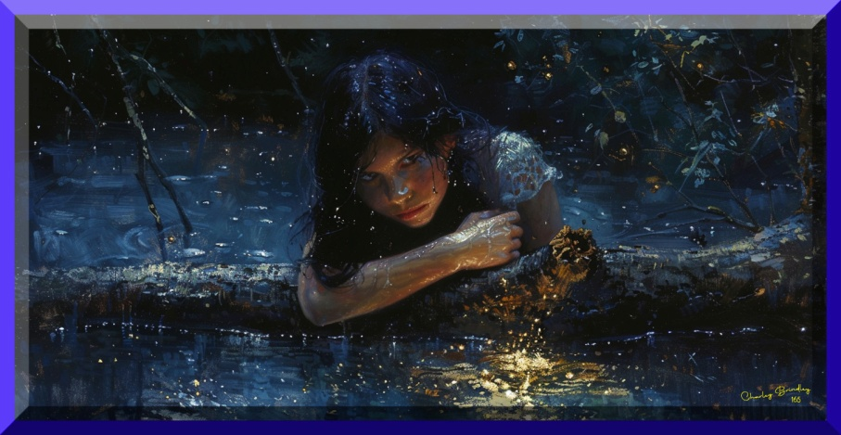

Why am I in the river?
Was I the only girl thrown over?
The current moved beneath me like a serpent coming to life. I brushed a strand of wet hair from my eyes and peered into the darkness.
Then I heard it.
At first, it sounded like distant thunder. Slowly, the rumble grew louder.
What is that?
The log I had climbed onto during the night began to turn, drifting toward the muddy bank. For a moment, I thought I might escape the freezing water.
Then the river dropped.
The current seized the log and hurled it forward.
Ahead, in the dim light of dawn, I saw what waited.
“Rapids!” I cried.
Massive boulders rose from the water like black teeth. I leapt from the log, trying to swim clear, but the furious river dragged me toward them.
A huge rock loomed ahead. I screamed, grabbing for anything to save me. I twisted away, but my head smashed into the stone, sending flashes of pain through my skull.
When I opened my eyes, I was pinned against the rock by another log. A slimy green growth covered the rotting bark, and two jagged limbs stuck out like broken arm bones. As I strained to push it away, a sharp pain shot from my head into my shoulders.
The roaring current caught my legs, pulling me into the rapids. I grabbed for the log but missed.
I crashed into the boulders and plunged through foaming whitewater until I tumbled into a deep pool.
When I surfaced, gasping for breath, the slimy log popped up beside me. I grabbed it, letting the eddy carry me around in a slow circle.
Every movement caused excruciating pain from the back of my head across to my temples. As I held on with one hand and lay back in the water, clouds and overhanging trees revolved in the morning sunshine.
Birds chirped in the palm trees, and a gentle breeze brought the earthy scent of dry land and flowering plants. Why am I in the river? My head hurt when I tried to concentrate. All I remembered was two men throwing me from a bridge. What happened to the others?
Exhausted from fighting the river, I had nothing left. My strength was gone, and the will to keep struggling had slipped away with it. I took a shallow breath and let go. As I sank into the cold depths, a strange calm settled over me while the spinning world faded into darkness.

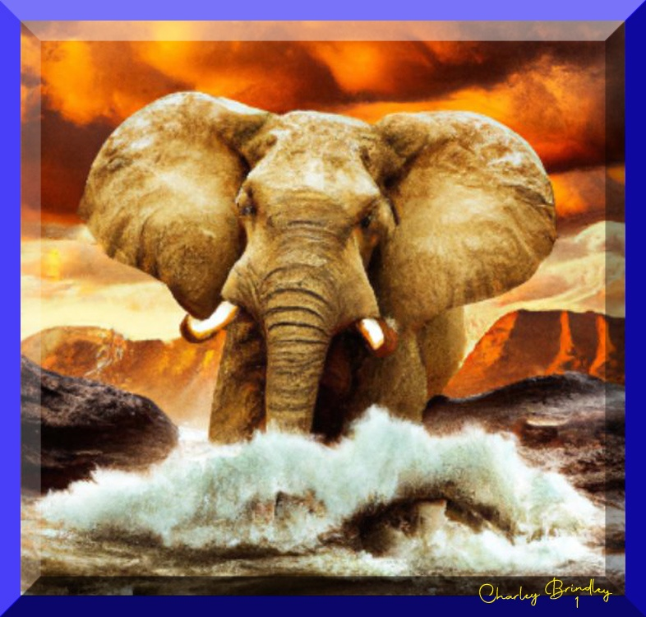

Then something moved in the water.
A creature seized me around the waist.
I thrashed and pushed, certain a giant water snake had wrapped itself around me. The serpent yanked me upward. My head broke the surface, but when I tried to scream, I only coughed and choked on the river water filling my lungs.
The snake tightened its grip.
I shoved against the writhing body, but it was far too strong. It lifted me higher until I stared into a massive eye surrounded by wrinkled gray skin. Terror froze me. I could only tremble in the creature’s grasp.
The beast blinked and shifted its hold, lifting me farther from its body. Two long horns curved from its mouth, sweeping past both sides of me.
I pushed with all my strength. “Let go!”
My shriek startled a flock of swallows from the palm trees. Their wings burst into the air with a sudden roar of flight.
The noise must have frightened the animal, because it released a deafening bellow that rattled my bones. The instant it loosened its grip, I grabbed the thing that held me.
It wasn’t a snake.
I had never seen such a creature before.
It was a long, curling trunk.
I wrapped my arms around it and clung tight. I didn’t want the monster to eat me, but I certainly didn’t want to fall onto those terrible horns either.
I screamed while the beast trumpeted, splashing and crashing backward toward the riverbank, trying to shake me loose. I held fast as it jerked its trunk high into the air, howling as if something had bitten it.
Perhaps in my desperation I had bitten it.
The creature staggered across the sand, crashing through brush until its backside hit an enormous carob tree. The tree shuddered from root to crown. Then a large dead limb snapped loose, crashing down onto the animal’s head.
The giant swayed.
Its eyes fluttered closed.
Then it collapsed in a thunder of dust, leaves, and broken branches. Its head struck a boulder, and the coiled trunk—with me still clinging to it—fell on its massive face.
I pushed myself upright, gasping for breath while brushing wet hair from my eyes.
I stared at the enormous gray beast lying in the sand.
“Did I kill him?”
Laughter erupted behind me.
I turned to see six soldiers approaching. They wore thick leather breastplates carved with scenes of battle, along with metal guards protecting their wrists and shins.
“Did you ever see such a sight?” one of them shouted.
A red-bearded man pointed a gnarled finger at me. His helmet gleamed in the morning light, long animal hair rising from the crest and running down the back. Each man carried a spear and wore a sword at his belt.
Another soldier tossed his shield onto the sand, laughing so hard he could barely speak.
“Obolus, the mighty war elephant, laid low by a child!” He slapped a comrade on the shoulder. “And a worthless half-girl at that. I doubt she has seen twelve summers.”
Wide leather strips trimmed with silver hung from their belts, forming protective skirts over their short tunics.
“The brave Obolus,” the red-bearded man said, grinning through crooked yellow teeth, “so fearless in battle he tramples a hundred men in a row. Yet a little river girl grabs his trunk, and straightaway he dies of fright!”
The men roared with laughter.
I wanted to run, but they closed in around me.

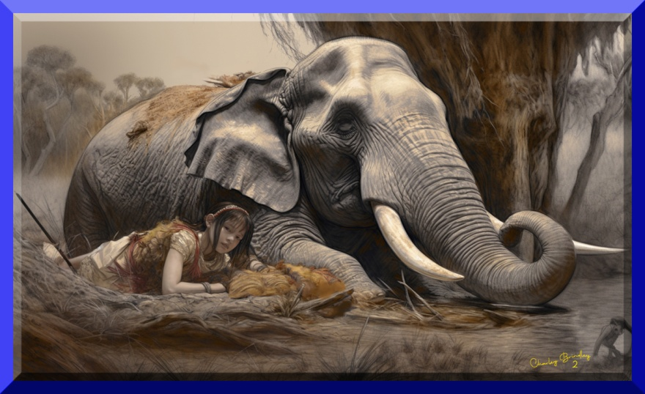

“Tonight we feast!” shouted a burly man with oily black hair. He set his helmet on the tip of his spear and waved it triumphantly. “Roasted leg of beast and elephant-ear stew!”
“Oh yes,” said Red Beard, drawing a dagger. “Two very large ears.”
He made a slicing motion through the air.
A cold shiver crept down my spine.
What are they going to do to me?
I wore nothing but a small loincloth, still dripping from the river.
Where am I?
My head throbbed when I tried to think. The men tightened their circle.
“This could be a grave matter,” Red Beard said, raising his voice so the others would hear. “We must pray our next battle is not against a legion of half-naked girls. Our war elephants would surely stampede to escape such a terrible army.”
More laughter.
He flipped his knife into a stabbing grip.
Just then a tall man carrying a staff pushed through the circle.
He wore a robe of deep red-violet, and his turban bore a golden emblem. A jeweled dagger hung from a woven belt at his waist. Though older than the soldiers, his back was straight and rigid.
The men immediately fell silent.
They stepped aside.
Red Beard quietly slipped his dagger back into its sheath.
The old man studied the fallen beast, then turned his gaze to me.
“An evil omen,” he murmured. “That is certain. Many must perish in sacrifice because of this sign from our goddess Tanit.”
The soldiers whispered among themselves. Clearly his words carried weight.
I slid off the animal and stepped back to look at the enormous creature lying in the sand.
Even on its side, it towered above me.
An elephant.
Is that what they called it?
A hand touched my shoulder, and I jumped away. When I turned, a young man I hadn’t seen before held out his cloak to me. He wasn’t a soldier, so I thought he must have arrived with the turbaned man. I took the cape and wrapped it around myself, shivering in fear of the soldiers and from the cold river.
The cloak brought warmth, but I felt a hundred different pains from all the cuts and bruises. My back, head…everything hurt, and exhaustion weakened my legs.
The man in the turban lifted his face to the sky and began a mournful chant. The soldiers prayed, leaning their spears in the crooks of their arms and clasping their hands before themselves. While the others mumbled toward the sky, the red-bearded soldier lowered his head to stare at me. A hungry animal couldn’t have frightened me more.
“Go now,” the young man whispered.
I stepped back, my feet tangling, and almost tripped. “Where?” I asked.
Unlike the soldiers, who were bushy-faced and boisterous, he was clean-shaven and soft-spoken. His brown eyes—the color of almonds and honey—were easy to look upon. He didn’t carry a weapon or wear armor, but he did have a sash around the waist of his white tunic. The sash was made of the same unusual cloth as the tall man’s robe.
He placed his hand on my back, guiding me away from the soldiers, toward the edge of the forest. “Hurry along that path to the camp and ask for the woman called Yzebel. She will find something for you to eat. Go quickly before Hannibal comes here and sees one of his elephants laid out on the ground.”
Painful though it was, I ran along the path leading into the woods. I was grateful for the comfort of his cape and knew I should have thanked him. The thick cloak was dappled in leafy green and shades of tan. It extended almost to the ground, covering me from shoulders to ankles.
I stopped and looked back, but the young man was gone.
The large lump on the back of my head hurt more than ever. When I touched it, pain shot across my forehead and into my eyes, making me dizzy.
If only I could lie down and sleep for a little while.
A patch of grass, like a soft green bed, lay beneath a nearby oak tree. When I took a step toward the grass, I heard noises in the distance. A dog barked and the clang of metal echoed through the forest.
The camp must be nearby.
I walked toward the sounds, too exhausted to run anymore.

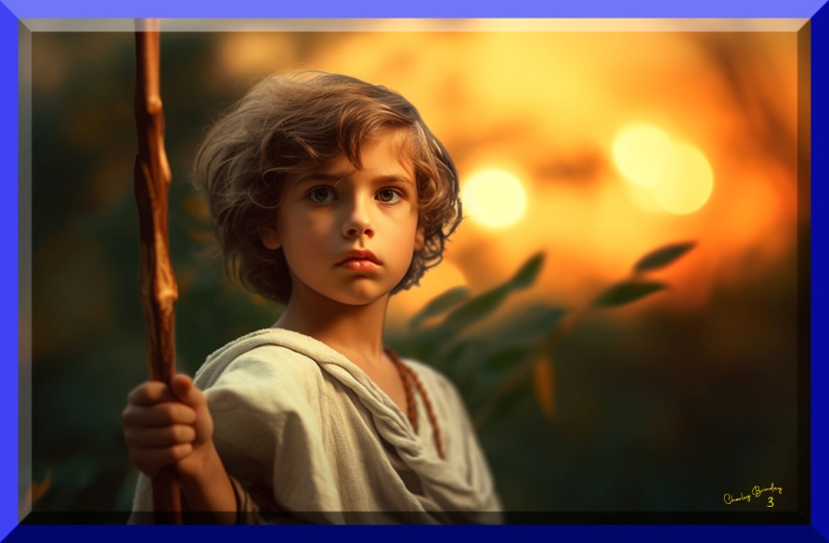

Near the path, a boy gathered wood. He wore a gray tunic and had his shaggy hair tied back with a leather string. He gave me a contemptuous sneer, and I wondered why. One of the sticks fell from his arm. He snatched it from the ground and cocked it back over his shoulder, as if to throw it at me. I kept my eyes on him and picked up a jagged stone the size of my fist, raising it in defiance. After surviving the river, the elephant with his long horns, and the frightening soldiers, I wasn’t going to be intimidated by a boy. He was taller than me, but I had the rock.
He swung his stick, hitting a nearby tree, then turned away, carrying his load of wood along the path. After he was out of sight, I continued in the same direction, keeping my rock handy.
Near the end of the trail, a slight breeze carried the delicious scent of food, making my empty stomach cramp with hunger pangs.
The path emerged from the pine forest, wound beside a large gray tent, and descended a gentle slope into the main camp. Many tents and wooden huts dotted a series of low hills, spreading across the landscape like a small city.
I followed the aroma of cooking food to the gray tent where a woman stood beside a fire in the morning sunshine, slicing vegetables into a simmering pot. Several tables with wooden benches circled the hearth.
She reached for a turnip and glanced my way, her honey-almond eyes narrowing on me.
“Where did you get that cape?”
I looked down, shuffling my feet in the dirt. I didn’t know what to say.
The woman approached me, knife in hand. I stepped back.
“That’s Tendao’s cape. Where did you get it?”
I pulled the cloak tighter around myself, then remembered the young man. He’d told me to ask for a woman who would give me something to eat.
“Do you know of Yzebel?”
“I’m Yzebel. Why do you wear Tendao’s cape and ask for me?”
She came closer and grabbed the cloak. I looked at the knife in her hand, then back at her face. Knots bulged in her clenched jaw, and her brow furrowed, distorting her beautiful features.
I held the cape closed, but Yzebel was too strong for me. She yanked it open. The sudden change I saw in her astonished me. Her stern features transformed so completely, it seemed another person had taken her place. The irritation and anger quickly softened into compassion and tenderness.
“Great Mother Elissa!” Yzebel stared at my bruised body. “What happened to you?”

